Measuring Guide
Dog Collars
It is important you measure your dog correctly. The best option is to measure the internal length of a current collar adjusted to how you like it fitted. To do this, remove the collar from your dog and do it up at the desired hole, then using a flexible tape, measure around the inside of the collar and the length will be where the middle hole will fit on your new collar. Or if you use the flexible tape measure to measure around the dogs’ neck where his collar would sit, allowing a little extra so that the collar is not too tight.
Belts
The best way is to measure your current belt from the inside of the buckle to the hole that is used most. You can also use a tape measure and measure around your waist where your belt will sit.
Belts will come with 5 holes as standard but on request will add 3 larger and 3 smaller holes for adjustment.
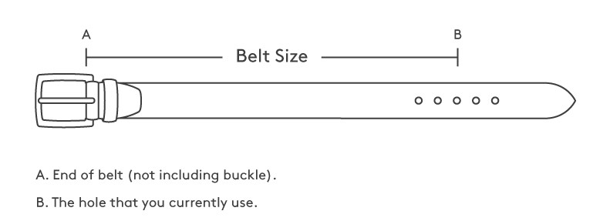
Bridle Work
Any sizing/style for bridle work to be discussed and agreed before any production commences.

